Spin Flush of Murine Bone Marrow Protocol
Materials
- 0.5 mL tube
- 1.5mL Eppendorf tube
- >500uL FACS buffer
- 18G sterile needles
- Sterile dissection scissors
- Sterile dissection tweezers
- Sterile dissection scalpel
- Kim wipes
Preparation
- Pierce the bottom of the 0.5mL tube with the 18G needle
  - Position the needle inside of the 0.5mL tube and push down from the outside
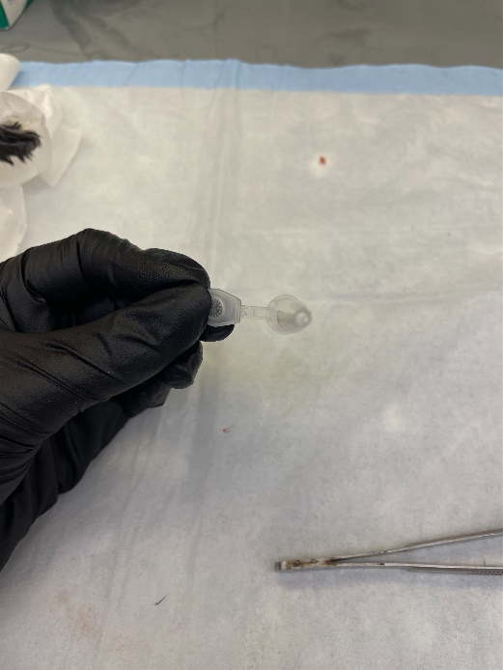
  - Pry off excess plastic from the piercing with the edge of the needle carefully, or with sterile tweezers

- Fill the 1.5mL Eppendorf tube with 150-200uL FACS buffer
- Place the 0.5mL Epitube upright into the Eppendorf tube
  - The hole will be submerged in the FACS buffer solution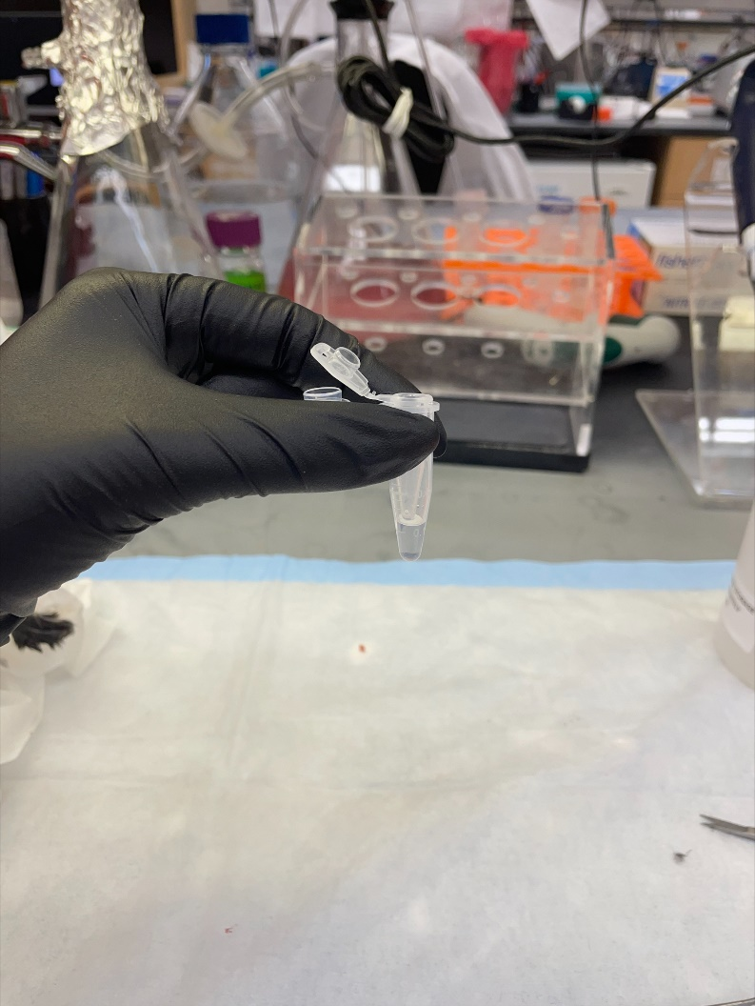
- Dissect the mouse and remove the femur and tibia
  - Remove all tissue on the bones using Kim wipes and tweezers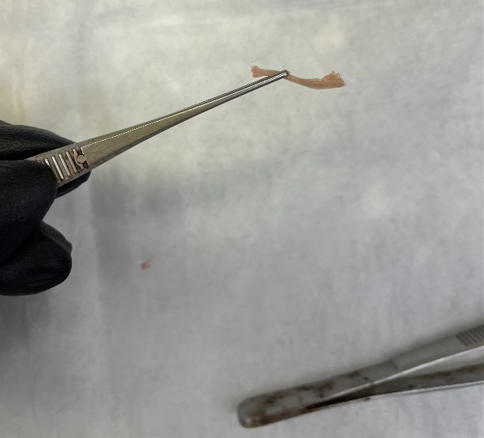

- Use the edge of the scissors, or scalpel, to pry open the tops of the femur and tibia
  - The “top” of the bones is the knuckle at which they join at the knee
  - Use a gentle back and forth motion to pry off the top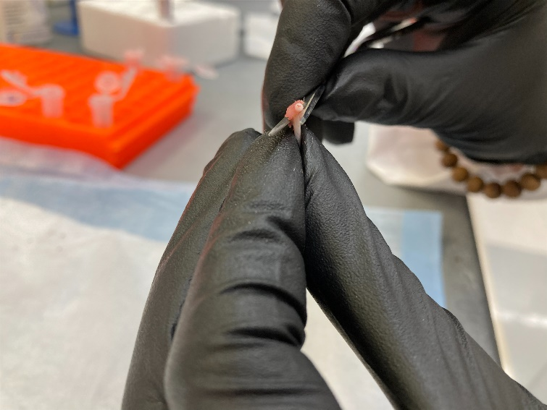
Protocol
- Use tweezers to drop the bones into the 0.5mL tube hole-side down
  - Close the cap of the tube

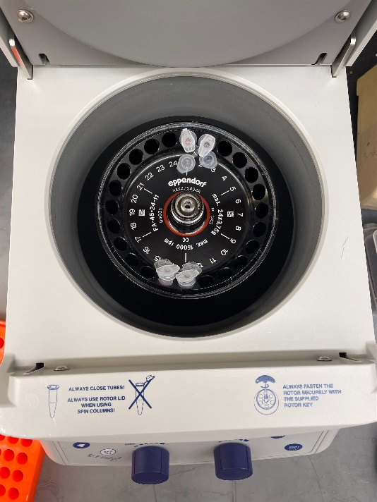
- Centrifuge at 10,000xg for 30 seconds at room temperature (tabletop centrifuge)
- Immediately after centrifugation:
  - Remove Epitube with bones (bones should be colorless/ translucent) and discard
  - Resuspend pellet with FACS buffer to avoid clumping
- [Optional Filtration] If working with multiple pellets from the same mouse:
  - Pool all resuspended cell pellets from the mouse into one 1.5mLtube
  - Filter pooled cells and FACS buffer through a blue filter top FACS tube (30um) or a 50mL conical tube with a 40um filter on top
    - Use a P1000 pipette tip
