Timed Mouse Pregnancies

- Isolate stud males for at least 1 week after previous mating
  - Either use older males (3-4 months) or proven studs
- Use 8-week-old females
  - Ideally 8-9 weeks (sexual maturity)
  - Nothing over 15 weeks (less reliable)
- House females together for 10-14 days
  - Synch estrous cycle
  - Increase length of diestrus phase
- Introduce soiled bedding from male cage 3 days before mating date
  - Syncs the female estrous cycles because of pheromone in male urine
- Only chose females in proestrus or estrus phase of estrous cycle in the afternoon
  - Examine outer genitalia for coloring, swelling, opening
- Add 1 or 2 females to each stud male’s cage
- Check for vaginal plugs in the morning
  - Indication that the mice have mated
  - NOT ALWAYS an indication of pregnancy
  - If present, consider this gestational day 0
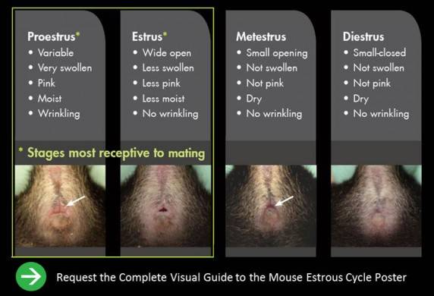
Tentative Schedule
Day -14
- Wednesday
- House 8-week-old females together
Day -7
- Wednesday
- House 3-month-old males individually
Day -3
- Monday
- Introduce male bedding to female cage
Day -1
- Tuesday
- Add 1-2 females to each male cage
Day 0
- Wednesday
- Check for vaginal plug
  - If present, mark as day 0
Days 1-15
- Check progress/ health periodically
Day 15
- Thursday
- Collect embryos

